**Chapter 6**

**Vector Calculus**

**6.5 Divergence and Curl**

**Section Exercises**

**For the following exercises, determine whether the statement is *true or false*.**

207.

Answer: False

209. If  then **F** is conservative.

Answer: True

211. If **F** is a constant vector field then 

Answer: True

**For the following exercises, find the curl of F.**

213.

Answer: 

215. 

Answer: 

217. 

Answer: 

219. 

Answer: 

221.  for constants *a*, *b*, *c*

Answer: 

**For the following exercises, find the divergence of F.**

223. 

Answer: 

225. 

Answer: 

227. 

Answer: 

229.  for constants *a*, *b*, *c*

Answer: 

231. 

Answer: 

**For the following exercises, determine whether each of the given scalar functions is harmonic.**

233. 

Answer: Harmonic

235. If  and  find 

Answer: 

237. Find the divergence of **F** for vector field .

Answer: 

**For the following exercises, use  and **

239. Find the 

Answer: 

241. Find the

Answer: 

**For the following exercises, use a computer algebra system to find the curl of the given vector fields.**

243. **[T]** 

Answer: 

**For the following exercises, find the divergence of F at the given point.**

245.  at 

Answer: 

247.  at 

Answer: 

249.  at (0, 0, 3)

Answer: 

**For the following exercises, find the curl of F at the given point.**

251.  at 

Answer: 

253.  at (1, 2, 1)

Answer: 

255. Let  For what value of *a* is **F** conservative?

Answer: 

257. Given vector field  on domain  is **F** conservative?

Answer: **F** is conservative.

259. Compute divergence 

Answer: 

**For the following exercises, consider a rigid body that is rotating about the *x*-axis counterclockwise with constant angular velocity  If *P* is a point in the body located at  the velocity at *P* is given by vector field** 

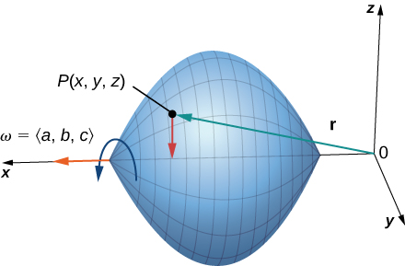

261. Express **F** in terms of **i**, **j**, and **k** vectors.

Answer: 

263. Find 

Answer: 

**In the following exercises, suppose that  and **

265. Does  necessarily have zero divergence?

Answer: does not have zero divergence.

**In the following exercises, suppose a solid object in  has a temperature distribution given by  The heat flow vector field in the object is  where  is a property of the material. The heat flow vector points in the direction opposite to that of the gradient, which is the direction of greatest temperature decrease. The divergence of the heat flow vector is **

267. Compute the divergence.

Answer: 

This file is copyright 2016, Rice University. All Rights Reserved.